PREMIER COMMUNITY HEALTHCARE APPOINTS DR. DELISA HERON
AS NEW CHIEF MEDICAL OFFICER

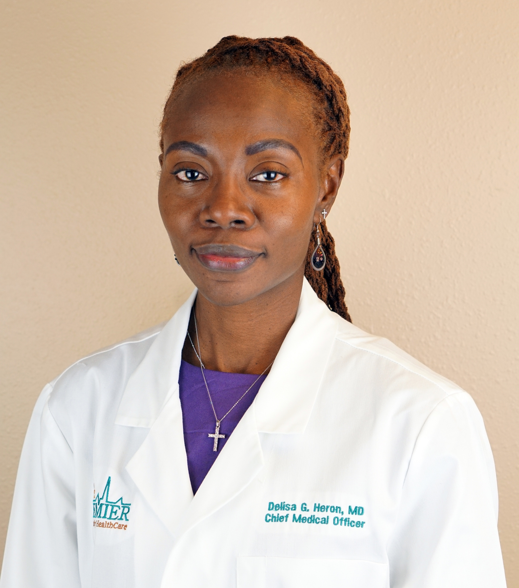
PASCO COUNTY, Fla., Wednesday, January 9, 2019 – Premier Community HealthCare Group, Inc. (Premier) appointed Dr. Delisa Heron as its new chief medical officer (CMO) to oversee clinical operations and leadership for 10 community healthcare centers throughout Pasco and Hernando counties. She will be succeeding Dr. Joseph W. King III.

“Dr. Heron’s robust skill set as a provider and leader will continue to advance our mission and clinical excellence across our organization,” stated Joey Resnick, chief executive officer of Premier. “Her passion and dedication for preventive care and meeting quality core measures will ensure that we continue to provide accessible, quality healthcare services for all.”

As the chief medical officer and a senior executive leader of Premier, Dr. Heron’s primary focus is to strengthen the patient-centered medical home model at the health centers and improve clinical outcomes of all patients. Prior to being promoted to CMO, Dr. Heron joined Premier as a primary care physician in 2015 and will continue to provide patient care at the Zephyrhills Family Health Center alongside her new role.

“I feel honored to succeed Dr. King and serve my colleagues and nearly 31,000 patients at Premier,” said Dr. Heron. “I look forward to continuing to elevate our quality of care and accessibility of services for our patients.”

After earning her medical degree at Ross University School of Medicine in Portsmouth, Dominica West Indies, Dr. Heron moved to New York and completed her residency at the Albert Einstein College of Medicine. Prior to joining Premier, she practiced medicine for a private practice in Newport News, Virginia.

