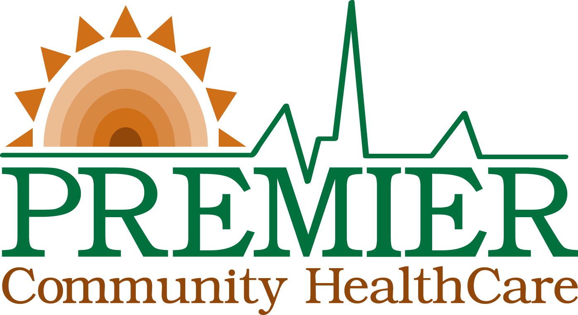

FOR IMMEDIATE RELEASE

Contact: Cheryl Pollock
Chief Development & Communications
cpollock@HCnetwork.org
352-518-2000 ext. 9012

BROOKSVILLE FAMILY HEALTH CENTER TO CELEBRATE ITS ONE-YEAR ANNIVERSARY
A free, open house event will celebrate the location’s first year as a primary health care facility for area residents.

Dade City, Fla., Friday, October 19, 2018 – On Saturday, Oct. 27, the Brooksville Family Health Center, one of 10 clinics operated by Premier Community Healthcare Group (Premier), will celebrate its one-year anniversary during an open house celebration from 9a.m. – 12p.m. The event will be held at the center facility co-located with the Florida Department of Health in Hernando County at 300 S Main Street.

Since opening during the summer of 2017, two new Premier clinics in Hernando County have improved access to medical and dental care for over 6,000 patients. Of those served, most (80 percent) are uninsured or publicly insured (Medicaid/Medicare). Of all patients served, 26 percent were children under 17 years-old (74 percent were adults) and 10 percent of all patients served scheduled a same-day appointment. These statistics demonstrate Premier’s dedication to providing high quality, affordable and available medical care to the community.

“Making health care more accessible for area residents was a main goal of the two new Premier clinics in Hernando County when we opened a year ago,” said Joseph Resnick, CEO of Premier. “We hope this milestone celebration will help further establish it as a medical home for children and families. We look forward to increased awareness of Premier’s Community Health Centers and serving even more patients as we enter the second year of operation.”
Community members throughout Hernando County are welcome to attend. Members of the media are also welcome and encouraged to attend to learn more about the Center and its role as a primary health care facility for area residents.

WHO: Brooksville Family Health Center
WHAT: Open house event celebrating its one-year anniversary with Premier leadership and staff. FREE services at event include:
- School Physicals
- Dental Screenings
- Health Screenings
- Educational Resources
- Refreshments and giveaways

WHEN: Saturday, October 27, 2018
9 a.m. – 12 p.m.

WHERE: Brooksville Family Health Center
300 S Main Street
Brooksville, FL 34601

VISUALS: Photography and video will be permitted to members of the media. To
schedule interviews, contact Cheryl Pollock at 352-518-2000 ext. 9012 or
CPollock@HCNetwork.org.

For more information about the event or Premier Community HealthCare, contact Zenaida Amador at zamador@hcnetwork.org or 352-518-2000 ext. 9505.

About Premier Community HealthCare Group
Officially known as Premier Community HealthCare Group, Inc. (PREMIER), the organization is a non-profit community health center dedicated to providing high quality, affordable, accessible medical care to Medicaid/Medicare recipients, uninsured and underserved communities of Pasco and Hernando Counties. With 10 conveniently located offices to serve patients, PREMIER provides a full range of comprehensive primary care medical services that include Family Medicine, Pediatrics, Dental, Behavioral Health, Obstetrics and Gynecology. PREMIER has been committed to serving the medically underserved areas with its long-standing presence in the community since 1979. Premier is one of nearly 1,400 community health centers nationwide created by federal legislation that provides some funding for the facilities. The centers are required by law to cater to medically underserved populations.
###

